**Comparision of Casino's of California and**

**Nevada using Four Square and Google Maps API**

**I. Introduction**: Many People in their vacations choose famous gambling places like Los Vegas or Los

Angeles which hosts lots of Casino’s.The Purpose of this project is to provide a quick insite of

Neighbourhood Casino's in these famous gambling destinations.

**II. Bussiness Problem:**

* To Compare Neighbourhood’s of Casino’s for both Nevada and California using Four
* Square API.
* To Provide a Quick Insight on the Famous Gambling destinations.
* To Compare the Hotels in both destinations

**III. Target Audience**

* Gamblers
* Tourists

**IV.Data Description**

There is primarily one source for the data containing list of casino’s, which is Wikipedia.

For extracting data from Wikipedia for list of casino’s and their respective states a famous python

library for WebScraping (BeautifulSoup) is used.

Later, for extracting hotels in the two destinations Four Square API is used to get the latitudes and

Longitudes.

**Source:**

1.) https://en.wikipedia.org/wiki/List_of_casinos_in_Nevada

2.) https://en.wikipedia.org/wiki/List_of_casinos_in_California

3.) <https://en.wikipedia.org/wiki/List_of_counties_in_Nevada>

4.) <https://en.wikipedia.org/wiki/List_of_largest_California_cities_by_population>

**V. Data Pre-Processing**

* Getting the data from web and converting the data into a dataframe.
* Filtering the casino’s and cities that doesn’t have latitudes and longitudes
* Removing null values from table.
* Using the Four square API and Google API to get the data.

VI. **Results and Maps**

a.) Califfornia Casino’s.

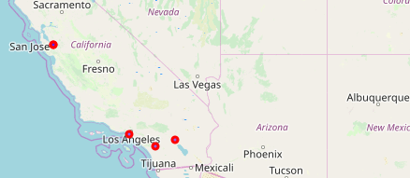

The Red highlighted circles represent the major casino concentration in the california area.

b.) Nevada’s Casino’s.

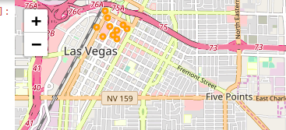

The Orange highlighted circles represent the major casino’s concentration in the Nevada area.

c.) California Hotel’s.

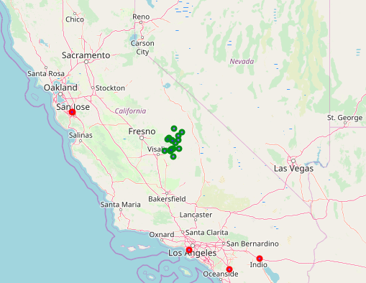

Hotels are represented by green Circles.

d.) Nevada Hotels

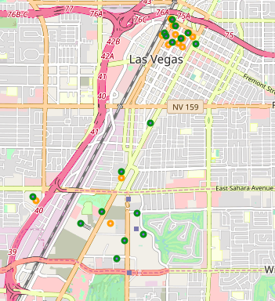

Hotels are represented by green Circles.

e.) California Parks

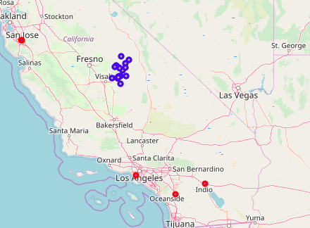

Parks are represented by Blue Circles.

f.) Nevada Parks

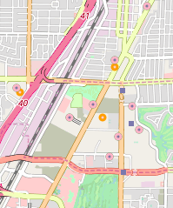

Parks are represented by orange Circles.

**VII. Conclusion**

In Nevada Casino's are more concentrated at Las Vegas.

* There are many hotels in Las vegas nearby Casino’s.
* In California casino's are spread at four locations(San Jose,Temecula,Los Angeles and Indio).
* In California Parks and hotels are concentrated away from highly populated areas of california like Los Angeles and from Csino’s.
* **For person to whom gambling is a hobby and doesn't care about other eminities vegas is a right fit.**
* **For a person to whom travelling is fun california would be a right pick.**

**VIII. References**

1.) https://en.wikipedia.org/wiki/List_of_casinos_in_Nevada

2.) https://en.wikipedia.org/wiki/List_of_casinos_in_California

3.) <https://en.wikipedia.org/wiki/List_of_counties_in_Nevada>

4.) https://en.wikipedia.org/wiki/List_of_largest_California_cities_by_population

5.) <https://cocl.us/coursera_capstone_report>